[Deep Learning A-Z™: Hands-On Artificial Neural Networks](https://www.udemy.com/course/deeplearning/) - Udemy

Input layer: an input to start the prediction.

Output: a value that we want to predict price, someone leaves the bank, someone stays.

Hidden layer: information comes through the senses, and it goes through billions and billions of neurons before it gets to the output.

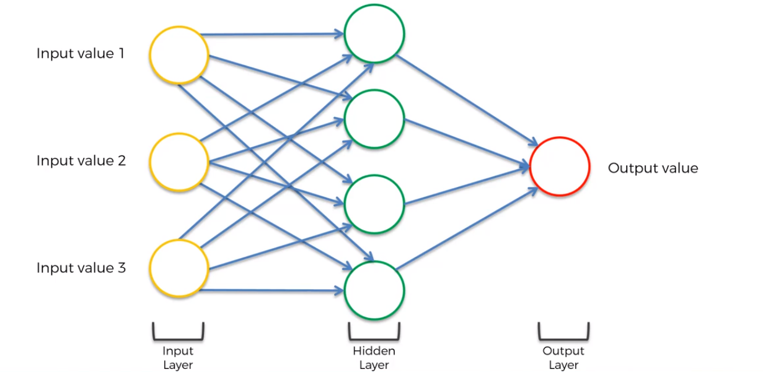

Deep learning: when we have lots of lots of hidden layers (just like a human brain).

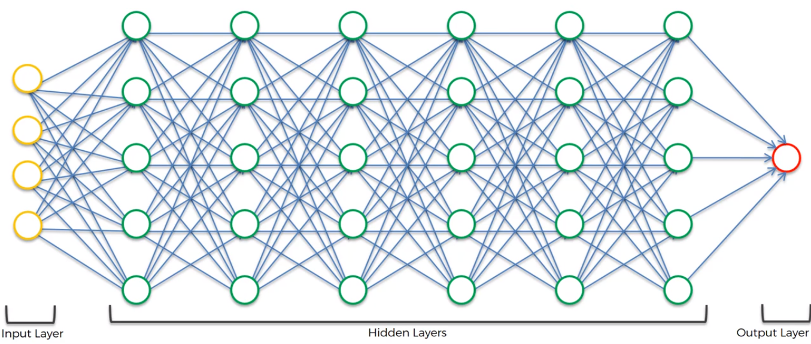

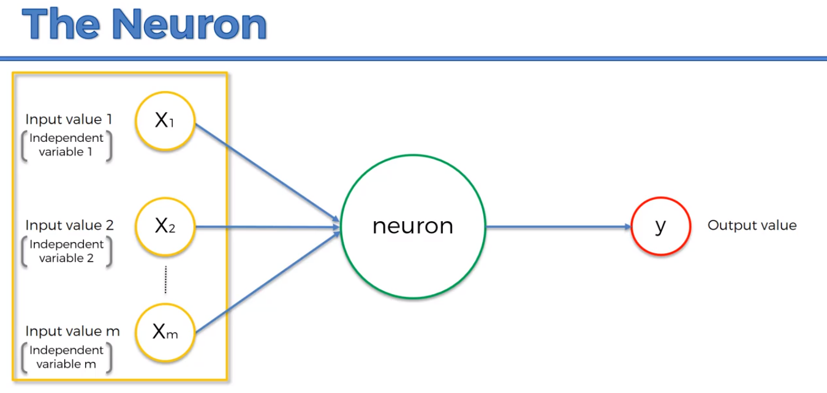

We need to standardize the variables, where they have a **zero mean** and **variance of 1. hi**